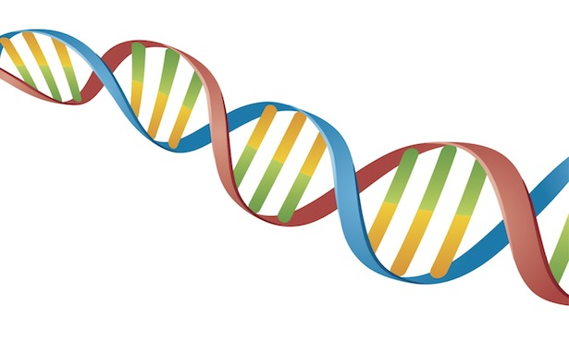

Year 11 Human Biology

Investigation

Extraction of DNA

Student Name: ______________________________

Assessment Date: ___________________________

I acknowledge that all the information contained in this task is my own work and not taken from other sources. If other sources have been used, they have been acknowledged in my references.

____________________________________

(Student Signature)

Teacher Comments:

Investigation and Validation worth 7% of final mark.

Investigation /27

Validation /18

Total /45

%

**Year 10 Laboratory Assessment - DNA Extraction**

DNA belongs to the group of acids originally found within the nucleus of the cells, hence the name nucleic acids.

We will extract DNA from fruit to investigate how it looks and feels. This procedure is similar to what scientists have to do before they can use the information contained in this DNA. This information can be used to improve crops so that they are more resistant to disease, insect invasion or changes in climate.

|  |  |
| --- | --- |
| http://www.apsnet.org/edcenter/K-12/TeachersGuide/PlantBiotechnology/PublishingImages/act1fig01.gifThe various chemicals used allow us to separate DNA from the cell. First of all, the cell wall needs to break open. The soap/detergent/extraction solution ruptures the outer part of the cell, while the salt helps separate DNA from other cellular chemicals, such as carbohydrates. Filtering removes most solid matter in the mixture. The last cooling helps the DNA solidify and precipitate. |  |
|  |  |

**Objectives**

* Extract DNA from plant cells
* Understand the general structure of cells

**Materials**

* 1-small zip lock bag
* 20 ml of extraction buffer (detergent, salt and water)
* ½ a Strawberry (~30 g per student pair)
* 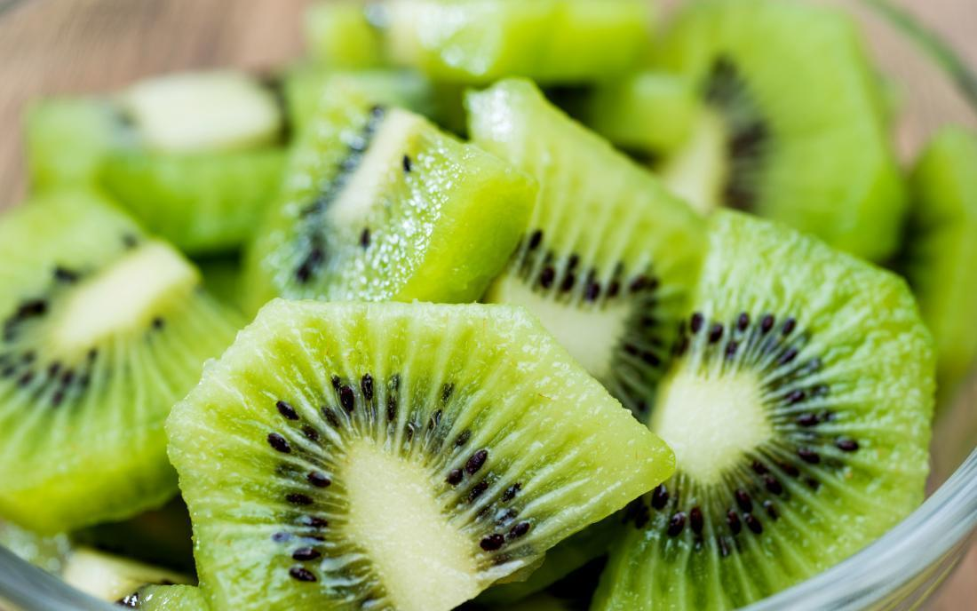500 ml beaker (class)
* Cheese cloth
* Ice
* Ice cold 95% ethanol (2 ml)
* 1 small test tube
* 1 wooden skewer
* 1 funnel
* 1 funnel stand

Q1. Risk Assessment: What do you think could be a risk during this experiment? **(1 mark)**______________________________________________________________________________________________________________________________________________________________________________

**Procedures:** You must show the teacher that you have completed each step of the procedure.

1. Cut your section of strawberry into smaller pieces and place in the zip lock bag.
2. Add 20mL extraction solution in the zipper bag. Close bag and CAREFULLY squeeze out air.
3. Crush the strawberry and extraction solution thoroughly for 5 minutes. Be CAREFUL not to break the bag!

**(1 mark have teacher initial these steps have been completed)**

1. Use the cheese cloth over a funnel to filter the mixture into a test tube.
2. Add approximately 2 ml of ice-cold ethanol to each tube by dropping it slowly down the inside of the test tube, allowing it to rest on top of the strawberry fruit mixture. Do not agitate (don’t mix) the solution.

**(1 mark have teacher initial these steps have been completed)**

**Diagram:** Draw what you see at the beginning of step 6 and **label** all equipment

**(5 marks)**

1. Let the solution sit for two minutes without touching it. The DNA strands should form where the filtrate and the isopropanol meet. This will appear as a transparent, slimy, white mucus which can be carefully removed with the wooden skewer.

**(1 mark have teacher initial these steps have been completed)**

**Contribution to group (write down how you contributed to your group during the lab): (1 mark)**_____________________________________________________________________________________________________________________________________________________________________________________________________________________________________________________________________

**Procedure Questions:** (Use the notes at the start of the experiment to answer the questions below)

1. Why do we “crush” the strawberry?

__________________________________________________________________________________________________________________________________________________________________ **(1 mark)**

1. Why do we use the buffer?

___________________________________________________________________________________________________________________________________________________________________________________________________________________________________________________  **(2 marks)**

1. What does the salt do?   
   ___________________________________________________________________________________________________________________________________________________________________________________________________________________________________________________  **(2 marks)**
2. What does the cold ethanol do?   
   __________________________________________________________________________________________________________________________________________________________________

**(1 mark)**

1. Why can’t we use room temperature ethanol?   
   __________________________________________________________________________________________________________________________________________________________________  **(1 mark)**

**Discussion Questions**

1. Why might DNA need to be extracted from something?   
   __________________________________________________________________________________________________________________________________________________________________ **(2 marks)**

2. Who might want to have DNA extracted from a cell?   
__________________________________________________________________________________________________________________________________________________________________

**(1 mark)**

3. What does DNA stand for?

________________________________________________________________________________________________________________________________________________________________________ **(1 mark)**

4. If you were able to zoom in on the extracted DNA, you would see the image below

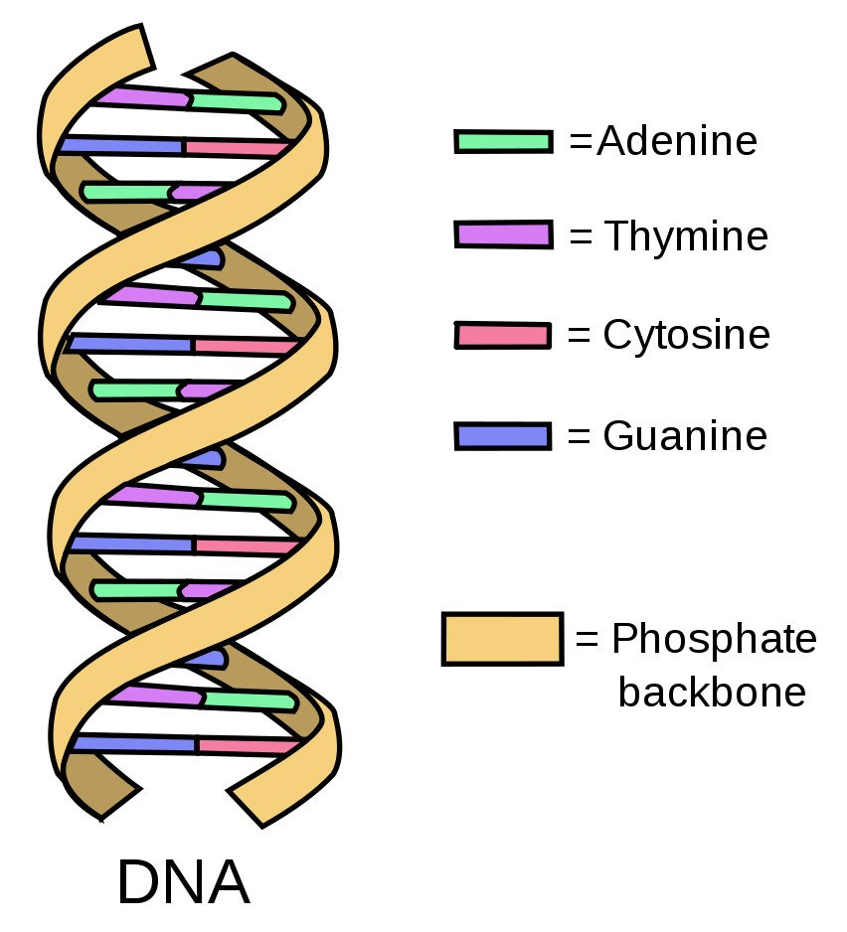

1. What are the names of the 4 nitrogenous bases in DNA?  
   **(2 marks)**
2. _______________________________
3. _______________________________
4. _______________________________
5. _______________________________
6. State the correct pairing of the nitrogenous bases   
   **(2 marks)**

Pair 1:____________________________________________________

Pair 2: ___________________________________________________

1. What is the backbone of the DNA molecule made of?  
   **(2 marks)**  
     
   ___________________________ and _____________________________